WATER QUALITY MANAGEMENT AND LEAKAGE DETECTION IN PIPELINE SYSTEM
N.Pavithra
Introduction:
According to Human Rights Watch, twenty million people in our country are still drinking water contaminated with arsenic. The World health Organization (WHO) has also stated this crisis as "the largest mass poisoning of a population in history”. To reduce the water related diseases and prevent water population, we have to measure water parameters such as pH, turbidity, conductivity, temperature etc. The main goal of this paper to build a Sensor based Water Quality Monitoring System and also Leakage Detection in Pipelines. This paper presents a small prototype using pH sensor and water flow sensor.

System Design:
- Arduino – open source PCB and IDE, based on ATmega328P microcontroller.
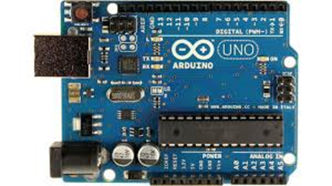
- pH sensor – It is an analog sensor manufactured by DF Robot.
- Flow sensor
- 16 x 2 liquid crystal display
- Piezoelectric Buzzer

Working:
- Initially the pH sensor and the turbidity sensor is placed in the water reservoir. If the pH of the water is not equal to 7 then the water is send for industrial purposes.
- Else the water is supplied for domestic purposes through pipelines. These pipes are fitted with water flow sensor to detect leakages. If the flow is more than the threshold value, it would indicate a leakage using the LCD and buzzer.
- These flow sensor can be placed for every 100m and hence the place of leakage can also be known using GPS.
- The interface used here is an Arduino which collects the input signals from the sensors and accordingly relays them to the LCD and buzzer.
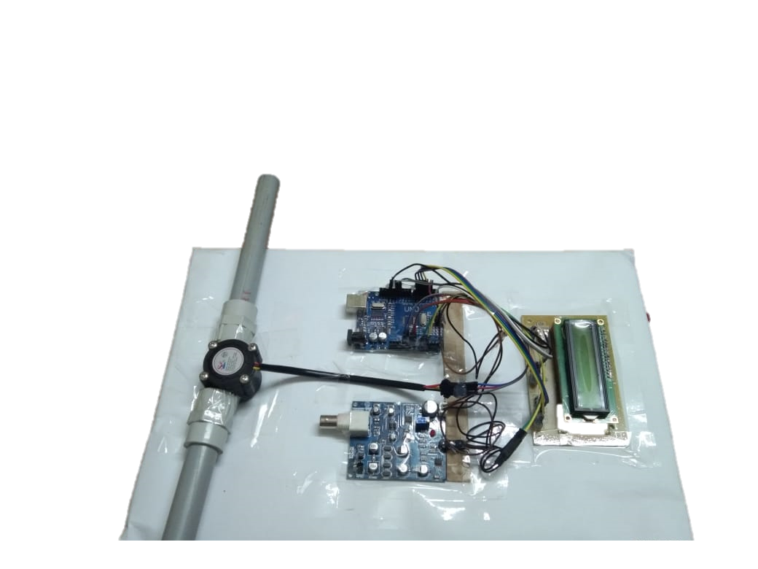

Arduino Uno

Future Work Scope:
We have solely focused only on measuring quality of water and also detecting leakage. This project can be extended into efficient water management system of a local area. A motor can be attached to the water pipe and hence it can control the water flow from one water carrier to another. This way we can reduce water consumption. Implementation of a GSM module along with GPS tracking can yield the exact position of leakage.

